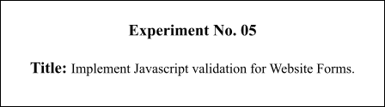

**Batch: B2 Roll No.: 16010421119 Experiment No.:5**

**Aim**: To Implement Javascript validation for Website Forms.

**Resources needed: Notepad++, Web Browser**

**Theory:**

JavaScript is a scripting language produced by Netscape for use within HTML Web pages. JavaScript is loosely based on Java and it is built into all the major modern browsers. JavaScript is a lightweight, interpreted programming language, Complementary to and integrated with Java , Complementary to and integrated with HTML , Open and crossplatform and is case sensitive.

Data validation is the process of ensuring that user input is clean, correct, and useful.

Typical validation tasks are:

* Has the user filled in all required fields?
* Has the user entered a valid date?
* Has the user entered text in a numeric field?
* Most often, the purpose of data validation is to ensure correct user input.

Validation can be defined by many different methods, and deployed in many different ways.

* Server side validation is performed by a web server, after input has been sent to the server.
* Client side validation is performed by a web browser, before input is sent to a web server.

For example HTML form validation can be done by JavaScript. If a form field (fname) is empty, this function alerts a message, and returns false, to prevent the form from being submitted:

function validateForm() {

var x = document.forms["myForm"]["fname"].value;

if (x == "") { alert("Name must be filled out"); return false;

}

}

**Activity:**

Add validations for the Website Forms Such as

1. Name should string
2. Roll number should a number
3. Email id should have @ and . in it
4. Telephone number should be a ten digit number.

**Students need to add various validations to their form input as per the requirement of the user interface.**

**Results: (Program printout with output)**

**import React, { useState } from 'react'**

**import './Signup.css'**

**import Button from '../../components/Button/Button'**

**import Message from '../../components/Message/Message'**

**import { useNavigate } from 'react-router-dom'**

**function Signup() {**

**const [username, setUsername] = useState('')**

**const [firstname, setFirstname] = useState('')**

**const [lastname, setLastname] = useState('')**

**const [phone, setPhone] = useState('')**

**const [email, setEmail] = useState('')**

**const [password, setPassword] = useState('')**

**const [cpassword, setCPassword] = useState('')**

**const [error, setError] = useState(false)**

**const navigate = useNavigate()**

**const handleUsername = (event) => {**

**setUsername(event.target.value)**

**}**

**const handlePassword = (event) => {**

**setPassword(event.target.value)**

**}**

**const handleSubmit = (event) => {**

**if (username === '' || password === '' || firstname === '' || lastname === '' || phone === '' || email === '') {**

**setError(true)**

**event.preventDefault()**

**return false;**

**}**

**else {**

**console.log([firstname, lastname, phone, email, username])**

**navigate('/')**

**}**

**}**

**return (**

**<div className='main-signup'>**

**<h2 className='login-text'>Signup</h2>**

**<form method='post'>**

**<div className='main-form'>**

**{error && <Message type='red' text='Please Fill All Fields' />}**

**<div className='main-name'>**

**<input type="text" value={firstname} name="text" className="input" onChange={(event) => { setFirstname(event.target.value) }} placeholder="First Name" />**

**<input type="text" value={lastname} name="text" className="input" onChange={(event) => { setLastname(event.target.value) }} placeholder="Last Name" />**

**</div>**

**<div className='main-name'>**

**<input type="number" pattern="\d{10}" maxLength='10' value={phone} name="text" className="input" onChange={(event) => { setPhone(event.target.value) }} placeholder="Phone" />**

**<input type="email" value={email} name="text" className="input" onChange={(event) => { setEmail(event.target.value) }} placeholder="Email" />**

**</div>**

**<div className='main-name'>**

**<input type="text" value={username} name="text" className="input" onChange={handleUsername} placeholder="Username" />**

**<input type="password" value={password} name="text" className="input" onChange={handlePassword} placeholder="Password" />**

**</div>**

**<Button text='Submit' click={handleSubmit} />**

**<h5>Already have an account??</h5>**

**<a href="/login" className='login-link'>Login</a>**

**</div>**

**</form>**

**</div>**

**)**

**}**

**export default Signup**

**Output:**

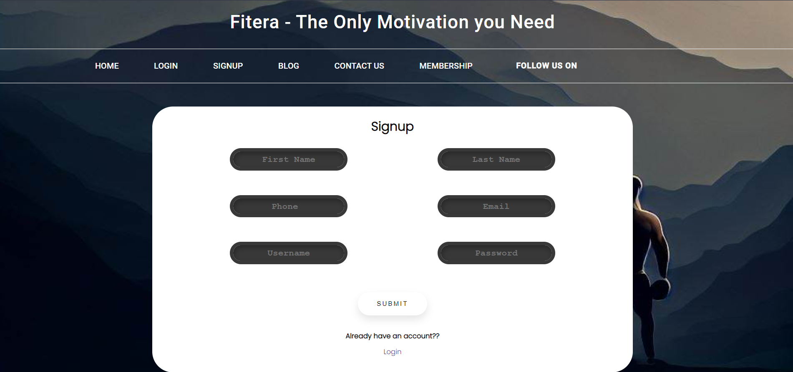

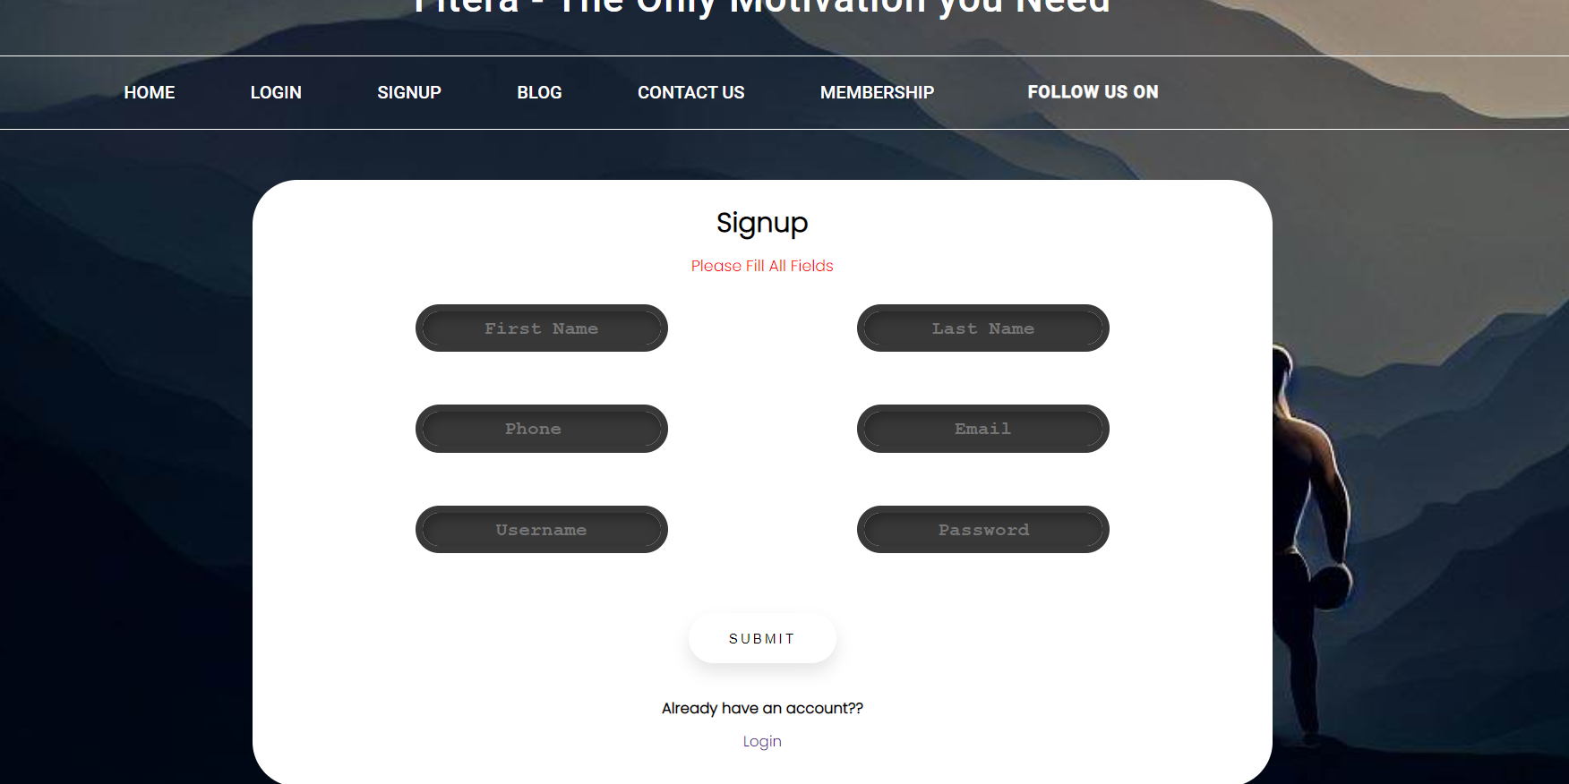

**Questions:**

**Q1) Why to carry out Validation at client side using scripting language?**

**Ans: -** In the Client Side Validation you can provide a better user experience by responding quickly at the browser level. When you perform a Client Side Validation, all the user inputs validated in the user's browser itself. Client Side validation does not require a round trip to the server, so the network traffic which will help your server perform better. This type of validation is done on the browser side using script languages such as JavaScript, VBScript or HTML5 attributes.

For example, if the user enter an invalid email format, you can show an error message immediately before the user move to the next field, so the user can correct every field before they submit the form.

Mostly the Client Side Validation depends on the JavaScript Language, so if users turn JavaScript off, it can easily bypass and submit dangerous input to the server . So the Client Side Validation can not protect your application from malicious attacks on your server resources and databases.

**Q2) What is the difference between client side validation and server side validation?**

**Ans:-** In the Server Side Validation, the input submitted by the user is being sent to the server and validated using one of server side scripting languages such as ASP.Net, PHP etc. After the validation process on the Server Side, the feedback is sent back to the client by a new dynamically generated web page. It is better to validate user input on Server Side because you can protect against the malicious users, who can easily bypass your Client Side scripting language and submit dangerous input to the server.

In the Client Side Validation you can provide a better user experience by responding quickly at the browser level. When you perform a Client Side Validation, all the user inputs validated in the user's browser itself. Client Side validation does not require a round trip to the server, so the network traffic which will help your server perform better. This type of validation is done on the browser side using script languages such as JavaScript, VBScript or HTML5 attributes.

**Outcomes:**

**CO3: Apply JavaScript and JSON for web application development**

**Conclusion: (Conclusion to be based on the outcomes achieved)**

**We can conclude that we have learnt about Form Validation.**

**Grade: AA / AB / BB / BC / CC / CD /DD**

Signature of faculty in-charge with date

**References:**

**Books/ Journals/ Websites:**

* “Web technologies: Black Book”, Dreamtech Publications
* [http://www.w3schools.com](http://www.w3schools.com/)